

**Name: Abdul Basit**

**Registration No: 5027**

**Department: BSSE**

**Teacher: SIR Zain Ul Islam Adil**

**Subject: Modern Programming Language**

Assignment No 02

**Table of Content**

**1 Introduction……………………………………………………………………………………**

**2 Project Name………………………………………………………………………………….**

**3 Language…………………………………………………………………………………………**

**4** **Task to Assign …………………………………………………………………………………**

**5 Output…………………………………………………………………………………………….**

Introduction

Basic login and registration form using Java language which take username and password from user and then authenticate it whether password or user name is correct or not otherwise it will show Error box invalid login .

Project Name

Login form

Language

Java

Task to Assign

This is our Assignment 02 of modern programming language have to create basic login or Registration form. if we put wrong information then login failed.

Output

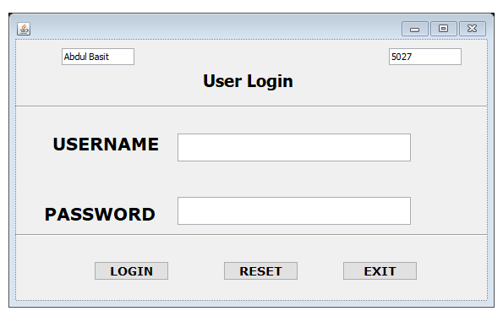

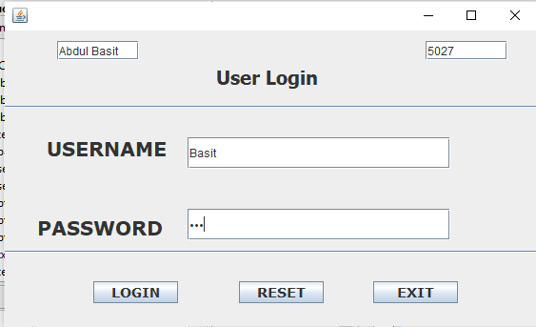

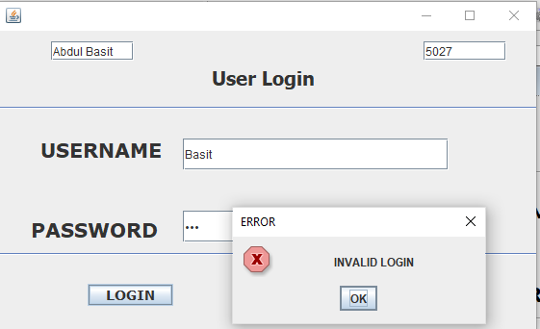

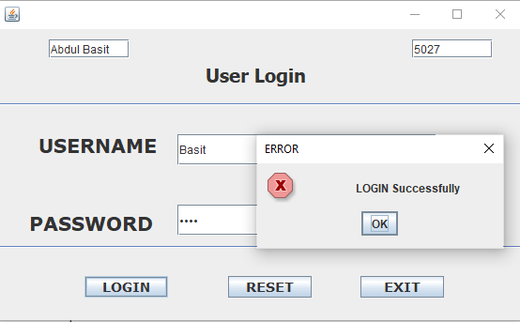

**Github link:**

**END**